

**Our apartment and modern conveniences**

**Worksheet**

**(*with answers to help the teacher*)**

**Name**___________________________________________________

**School №** ________________________________________________

**Grade** ___________________________________________________

**Правила работы:**

− внимательно читайте задания, отвечайте на вопросы, используйте материалы к уроку, ответы и решения оформляйте письменно;

− активно используйте информационное пространство музея;

− при необходимости задавайте вопросы с целью получения необходимых сведений и данных;

|  |  |
| --- | --- |
| ! | После выполнения всех заданий вернитесь в вестибюль для подведения итогов урока. |

**Introduction**

Today, Moscow is one of the most attractive and livable cities in the world. This is the result of many years of well-planned and consistent work performed by the professionals from all the units of municipal infrastructure of the city of Moscow. Hundreds of thousands of specialists work around the clock to complete a variety of specific tasks, and without them the metropolis wouldn’t be able to survive a day. The Museum of Municipal Infrastructure of the City of Moscow tells about how this technologically advanced mechanism works providing all the conveniences and forming a safe environment for life.

**Exhibition hall *Apartment***

We really got so accustomed to having a comfortable everyday life that we don’t even think about what makes all these conveniences possible.

Where do tap water, gas, and electricity come from? How do they get into our home?

Today we are going to learn about how modern conveniences make their way to our homes.

**Scheme of the exhibition hall *Apartment***

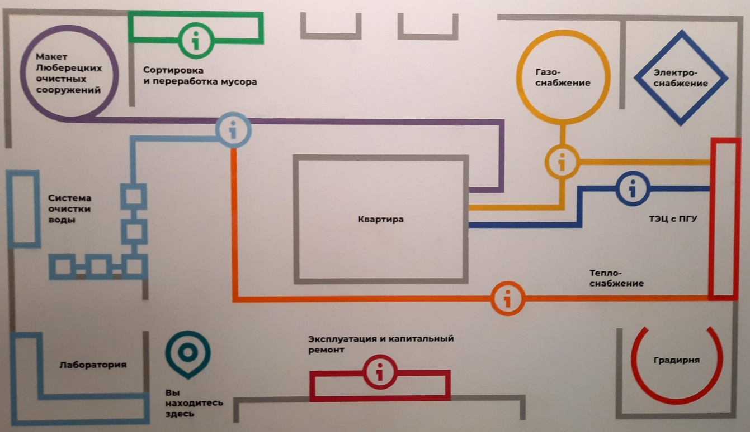**Task 1.** Before you visit the first level of the museum, study the scheme of the exhibition hall *Apartment*.

Match the Russian names of the thematic areas of the hall with their English equivalents.

|  |  |
| --- | --- |
| 1. Сортировка и переработка мусора | 1. Electric power supply |
| 1. Макет Люберецких очистных сооружений | 1. Maintenance and capital repairs |
| 1. Система очистки воды | 1. Cooling tower |
| 1. Лаборатория | 1. Gas power supply |
| 1. Эксплуатация и капитальный ремонт | 1. Schematic diagram of TPP |
| 1. Квартира | 1. Heating power supply |
| 1. Градирня | 1. Waste sorting and recycling |
| 1. Теплоснабжение | 1. Model of Lyubertsy water treatment facilities |
| 1. ТЭЦ с ПГУ | 1. Laboratory |
| 1. Электроснабжение | 1. Apartment |
| 1. Газоснабжение | 1. Water purification system |

Write down the selected letters under the appropriate numbers in the table.

|  |  |  |  |  |  |  |  |  |  |  |
| --- | --- | --- | --- | --- | --- | --- | --- | --- | --- | --- |
| 1 | 2 | 3 | 4 | 5 | 6 | 7 | 8 | 9 | 10 | 11 |
| G | H | K | I | B | J | C | F | E | A | D |

**Maintenance and capital repairs**

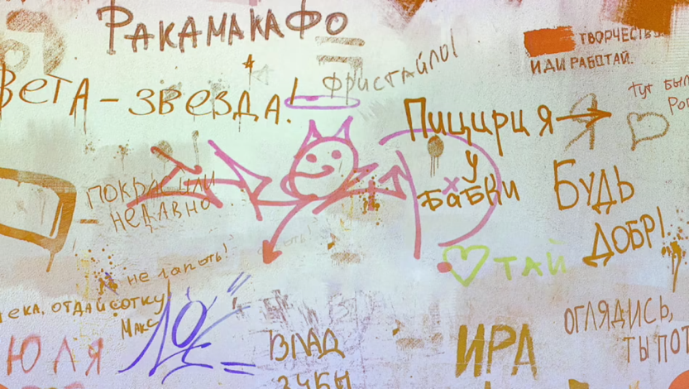

**Task 2.** In the thematic area *Maintenance and capital repairs*, paint over the graffiti on the interactive wall and learn about the features of a capital repair.

Read the following texts and compare the information from the texts with the information presented in the Russian language. Each text contains a mistake. Put down the wrong word from the text in the left column and the correct answer in the right column.

1. During the demolition of 2013-2015, O. P. Korobkova's Mansion on Pyatnitskaya Street, designed by Lev Kekushev at the turn of the XIX-XX centuries, returned to the former unusual purple color.

|  |  |
| --- | --- |
| demolition | restoration |

1. The list of permitted colors for painting city buildings was introduced by Alexander I in 1816. It was forbidden to use «rough colors» - green, red, cherry, blue. Preference was given to light colors - blank, fawn, bright yellow, yellow-gray.

|  |  |
| --- | --- |
| bright | pale |

1. Regularly updated color schemes have been specially designed for the facades of typical city buildings. Colors should match the style and location of the building, be disgusting to look at.

|  |  |
| --- | --- |
| disgusting | pleasant |

1. There is a law that regulates graffiti on Moscow buildings. A special committee banned more than 800 pieces of graffiti in the first 6 months of 2022.

|  |  |
| --- | --- |
| banned | approved |

1. A fresco was found under a layer of paint during the restoration of the Church of Michael and Theodore of Chernigov in Zamoskvorechye in 2012-2015. Today it is the largest indoor wall fresco that can be found in Moscow.

|  |  |
| --- | --- |
| indoor | outdoor |

**Info modules**

**Task 3.** At the entrance of each thematic area, you will find an *Info module* with the logo of the area. Go back to the scheme of the exhibition hall *Apartment* and find the *Info modules* on it.

Answer the question.

How many *Info modules* are there in the hall?

There are 6 info modules.

You are right!

Find Info module *Water supply and disposal in Moscow,* watch the video and answer the questions.

1. When was plumbing system introduced in Moscow?

In 1804.

2. How many years did it take to build the system?

It took 25 years to build the system.

3. Is water still disinfected with bleach?

No, it isn’t.

4. Is tap water suitable for drinking?

Yes, it is.

5. When was sewerage introduced in Moscow?

In 1898.

**Laboratory**

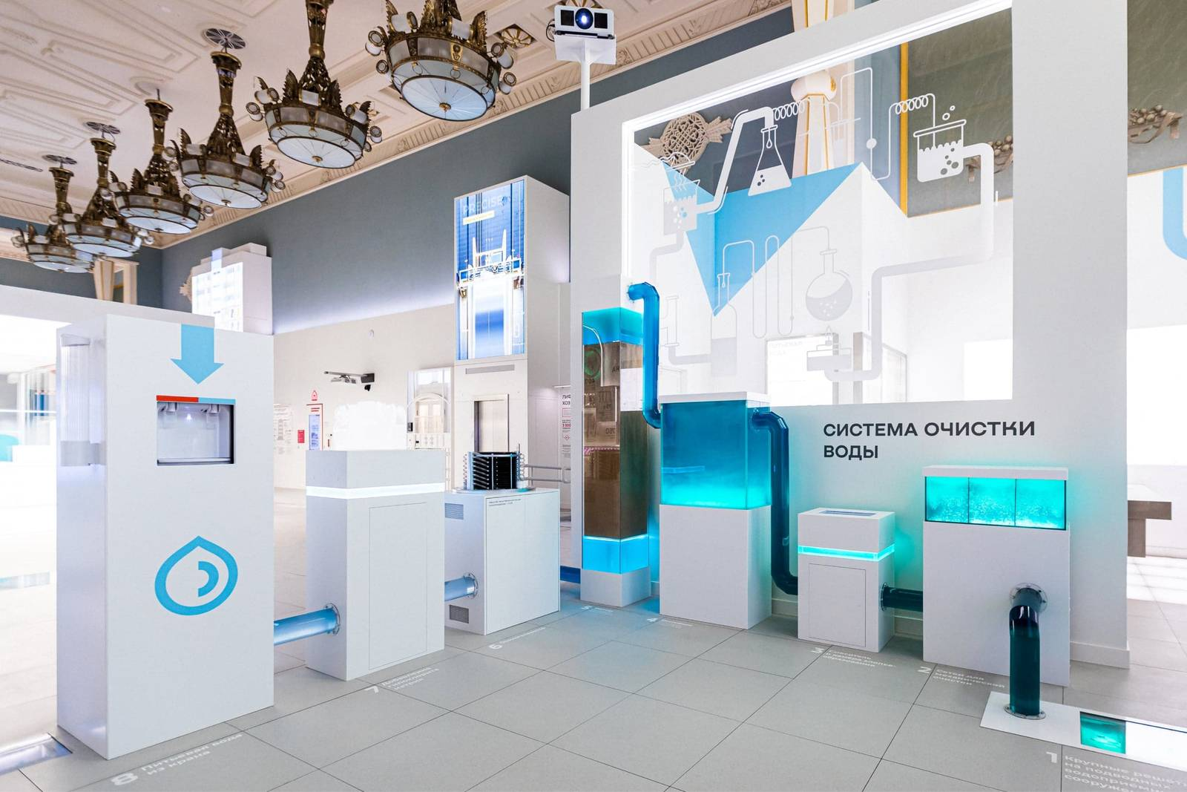

**Task 4.** In the thematic area *Laboratory* find the info panel *Water quality analysis*. Examine the section *Substances present in water after treatment in the water supply system* and answer the question below.

What substances shouldn’t be detected in drinking water supply system?

Total Coliforms and Thermotolerant Coliforms Bacteria shouldn’t be detected in drinking water supply system.

**Task 5.** Find a substance whose standard in drinking water is not more than 0.3 mg/dm3.

You are right. It is iron.

What does dm3 mean? Choose the correct answer.

Dm3 is …

A. a barrel B. a quart C. a liter D. a pint

**Task 6.** Read the text and answer the questions.

**Iron**

Drinking water standard according to SanPIN 2.1.4.1074-01

not more than 0.3 mg/dm3

Iron is a metal present in water in several forms. Trivalent iron gives water a yellow tint and settles as a brown sediment. Divalent iron dissolves well and does not color water, but after contact with air it precipitates: often you can notice a yellow plaque at the place of water drainage in the washbasin, bath or toilet. Bacterial iron creates jelly-like deposits in the water main.

Natural ground waters of Moscow and Moscow region have increased iron content. High iron content makes water unsuitable for drinking and industrial purposes.

It is proved that a single consumption of water with an admixture of iron does not harm the body, but its regular consumption can cause adverse effects (allergic reactions, liver disorders, thyroid problems).

1. What is iron?

Iron is a metal present in water in several forms.

2. What iron doesn’t color water?

Divalent iron does not color water.

3. What does bacterial iron create?

Bacterial iron creates jelly-like deposits in the water main.

4. How does high iron content affect water?

High iron content makes water unsuitable for drinking and industrial purposes.

5. How does regular consumption of water with an admixture of iron harm the body?

Regular consumption can cause adverse effects (allergic reactions, liver disorders, thyroid problems).

**Task 7.** Make appropriate word combinations by matching the words from the 2 columns.

|  |  |  |  |  |  |
| --- | --- | --- | --- | --- | --- |
|  | F | in several |  |  | iron |
|  | I | a brown |  |  | disorders |
|  | A | bacterial |  |  | purposes |
|  | D | jelly-like |  |  | deposits |
|  | J | unsuitable for |  |  | consumption |
|  | C | industrial |  |  | forms |
|  | E | a single |  |  | problems |
|  | H | allergic |  |  | reactions |
|  | B | liver |  |  | sediment |
|  | G | thyroid |  |  | drinking |

**Task 8.** Match the phrases from task 7 with their meanings.

|  |  |
| --- | --- |
| in several forms | в нескольких видах |
| a brown sediment | бурый осадок |
| bacterial iron | бактериальное железо |
| jelly-like deposits | желеобразные отложения |
| unsuitable for drinking | непригодный для питья |
| industrial purposes | технические цели |
| a single consumption | разовое потребление |
| allergic reactions | аллергические реакции |
| liver disorders | нарушение работы печени |
| thyroid problems | проблемы с щитовидной железой |

**Conclusion**

So, we have found out where tap water comes from and how it gets into our home. How difficult it is to purify water so that it becomes drinkable.

Let's take care of drinking water. We can save water in our apartments. Here are some tips on how to save water at home.

* 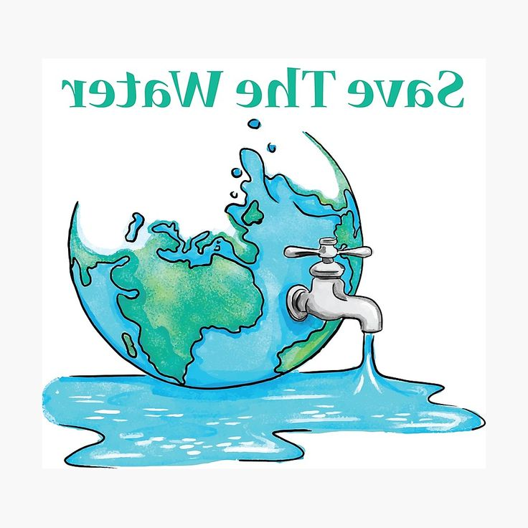Turn off the water when you brush your teeth.
* Use a lever tap instead of a valve tap.
* Take a shower, not a bath.
* Reduce the time spent in the shower.
* Don't wash the dishes under running water.
* Do the washing only when the machine is fully loaded.
* Install a toilet bowl with two drain modes.
* Don't use the toilet as a trash can.
* Keep an eye on the plumbing, don’t allow water leaks.
* You can also save water by collecting rainwater to water plants.

**Explanation of homework.**

You have received an email message from your English-speaking pen-friend Duncan:

|  |
| --- |
| **From:** [**Duncan@mail.uk**](mailto:Duncan@mail.uk) |
| **To: [Russian_friend@oge.ru](mailto:Russian_friend@oge.ru)** |
| **Subject: Visiting a museum** |
| …Last Thursday, my dad and I decided to take a trip to the Quetta Museum, a stunning Archaeological Museum. He wanted me to learn more about the history of our country, and this museum was a perfect place to start with…  … When was the last time you went to the museum? What type of museum was it? Were there any interactive exhibitions in the museum?... |

Write a message to Duncan and answer his **3** questions.

Write **100-120 words.**

Remember the rules of email writing.

**Summing up the lesson.**

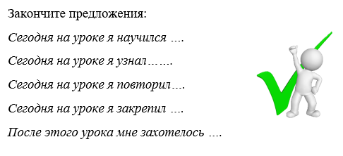Now the lesson is coming to an end. You have worked very hard today. I’m sure it was a very unusual and interesting lesson. I’m pleased with your answers and you’ll get good marks today.

- What have you learnt?

- What did you like about our lesson?

Thank you for your work. Our lesson is over.